**Alpha Picks Weekly Market Recap**

Mar. 28, 2025 3:44 PM ET



[Seeking Alpha](https://seekingalpha.com/author/seeking-alpha#source=url_first_level%3Aalpha-picks%7Csection%3Ampb%3Aauthor_unit%3Aseeking-alpha%7Csection_asset%3Ampb%3Aauthor_unit%7Cauthor_name)

[Investing Group Leader](https://seekingalpha.com/checkout/mp_1409#source=url_first_level%3Aalpha-picks%7Csection%3Ampb%3Aauthor_unit%3Aseeking-alpha%7Csection_asset%3Ampb%3Aauthor_unit%7Cauthor_badge)

[Comments](https://seekingalpha.com/alpha-picks/articles/6137471-alpha-picks-weekly-market-recap" \l "scroll_comments)

[(15)](https://seekingalpha.com/alpha-picks/articles/6137471-alpha-picks-weekly-market-recap" \l "scroll_comments)

**Summary**

* Major indices dipped as President Trump’s 25% auto tariff announcement rattled markets. The S&P 500 slipped 2.80% for the week, while the Dow and the Nasdaq fell 1.95% and 4.21%.
* Automakers bore the brunt of the market slide with General Motors (GM) plunging over 8% for the week.
* BlackRock (BLK) expanded its crypto footprint with a European Bitcoin ETP. GameStop’s $1.3B plan to convert cash to Bitcoin fueled crypto volatility for the week.
* Q4 2024 GDP revised up to 2.4%, with job openings rising to 7.74M in January, signaling labor market resilience in advance of Tuesday’s February JOLTS report.



Parradee Kietsirikul

**Auto Tariffs Roil Markets**

President Trump’s 25% tariff on non-U.S. auto imports, effective April 3rd, triggered a sector-wide selloff. On Thursday, General Motors ([GM](https://seekingalpha.com/symbol/GM)) plunged over 7%, Japanese automakers Toyota ([TM](https://seekingalpha.com/symbol/TM)) and Honda ([HMC](https://seekingalpha.com/symbol/HMC)) slid over 2.5%, meanwhile, Tesla ([TSLA](https://seekingalpha.com/symbol/TSLA)) was up 2.5%. The policy aims to restore U.S. manufacturing but risks inflating car prices and may add to core CPI while disrupting supply chains. Bank of America ([BAC](https://seekingalpha.com/symbol/BAC)) warned of near-term consumer pain, with repair costs and insurance premiums likely rising as tariffs hit foreign parts, and companies requesting exemptions.

"Given the meaningful impact of the tariffs across the automotive industry and broader economy, we expect a flurry of activity to the latest announcements from companies, governments, industry lobbyists and other parties," [highlighted](https://seekingalpha.com/news/4425598-us-tariffs-a-flurry-of-deals-could-stave-off-major-pain-for-consumers?source=first_level_url%3Aalpha-picks%3Aarticles%7Ccontent_type%3Aall%7Csection%3Aapb_article%7Csection_asset%3Abody_link%7Cservice_id%3A1409%7Cservice_name%3AAlpha%20Picks%7Cservice_level%3Abasic) analyst John Murphy.”

While exemptions may soften the blow, Detroit automakers like Ford ([F](https://seekingalpha.com/symbol/F)) and Stellantis ([STLA](https://seekingalpha.com/symbol/STLA)) still dropped on associated risks with Mexican and Canadian suppliers.

[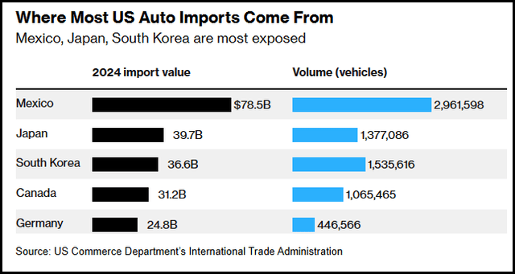](https://static.seekingalpha.com/uploads/2025/3/28/56421291-17431900474338322_origin.png)

Bloomberg

Source Link: [Bloomberg](https://www.bloomberg.com/news/articles/2025-03-26/trump-prepares-auto-tariff-announcement-as-soon-as-wednesday?srnd=homepage-americas)

While most U.S. auto imports arrive from Mexico and Japan, nations like South Korea and Germany are exposed, which poses significant challenges. Supply chain constraints and retaliatory tariffs are likely to dampen sales and profit margins in the already competitive global market.

**Macro Highlight - April JOLTS**

While the Federal Reserve kept rates steady and the latest labor market insights revealed a resilient job market in advance of February’s Job Openings and Labor Turnover Survey (JOLTS). Recent data pointed to an increase in layoffs and discharges, signaling possible shifts in employment stability, contrasting with the broader narrative of strong job openings, suggesting that while companies are eager to hire, they are becoming more discerning in their workforce management.

[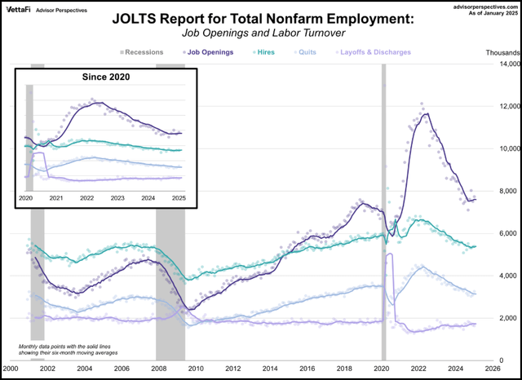](https://static.seekingalpha.com/uploads/2025/3/28/56421291-17431900476923656_origin.png)

Advisor Perspectives

Source Link: [Advisor Perspectives](https://www.advisorperspectives.com/dshort/updates/2025/03/11/jolts-report-job-openings-january-2025)

As businesses brace for potential cost increases from auto tariffs and ongoing geopolitical tensions, the labor market could face new headwinds, creating a complex environment for both employers and workers in the coming months.

**Geopolitical Events**

The recent [closure of Heathrow Airport](https://seekingalpha.com/news/4424188-national-grid-ceo-says-heathrow-airport-had-enough-power-despite-shutdown?source=first_level_url%3Aalpha-picks%3Aarticles%7Ccontent_type%3Aall%7Csection%3Aapb_article%7Csection_asset%3Abody_link%7Cservice_id%3A1409%7Cservice_name%3AAlpha%20Picks%7Cservice_level%3Abasic) due to a substation fire amplified discussions around aviation resilience. The incident grounded over 1,300 flights, affecting approximately 250,000 passengers and disrupting one of Europe’s largest air travel hubs. This event highlighted the need for enhanced risk management strategies in the aviation sector and pressed authorities to ensure that airports can swiftly adapt to unforeseen disruptions.

The Israeli-Hamas war persists, and [safe-haven inflows](https://seekingalpha.com/article/4768755-go-for-gold-2-gold-etfs-to-beat-volatility?source=first_level_url%3Aalpha-picks%3Aarticles%7Ccontent_type%3Aall%7Csection%3Aapb_article%7Csection_asset%3Abody_link%7Cservice_id%3A1409%7Cservice_name%3AAlpha%20Picks%7Cservice_level%3Abasic) continue as investors seek defense and safety amid trade and geopolitical tensions. Trade tensions escalated as Japan and Canada [vowed retaliation](https://seekingalpha.com/news/4425540-trump-auto-tariffs-japan-canada-response?source=first_level_url%3Aalpha-picks%3Aarticles%7Ccontent_type%3Aall%7Csection%3Aapb_article%7Csection_asset%3Abody_link%7Cservice_id%3A1409%7Cservice_name%3AAlpha%20Picks%7Cservice_level%3Abasic) against U.S. tariffs. Canada’s Mark Carney labeled the move “a very direct attack…"We will defend our workers. We will defend our companies. We will defend our country.” Meanwhile, Ontario Premier Doug Ford threatened “painful” countermeasures on the American people without inflicting pain on the Canadian population. Mexico sought preferential treatment, arguing that it exports nearly 3 million vehicles and 40% of the auto exports the U.S. buys.

Eurozone equities slid on fears of Trump’s reciprocal tariff plan (April 2), while Asian indices wavered as South Korea prepared emergency support for automakers.

**GICS Sector Performance**

Despite the tariff impacts and announcements affecting the auto industry, the Consumer Discretionary ([XLY](https://seekingalpha.com/symbol/XLY)) sector rallied as the top-performer for the week.

**Consumer Discretionary rallied this week.**

[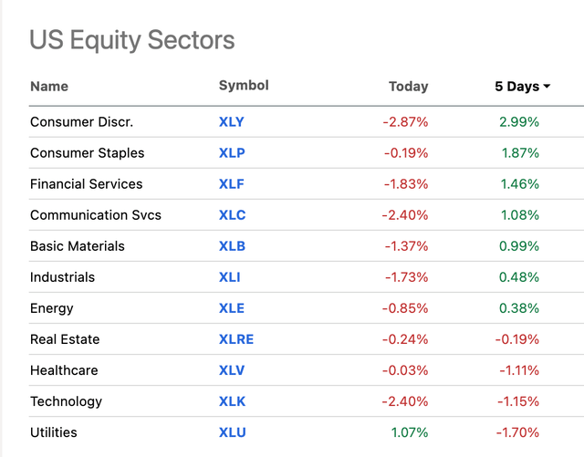](https://static.seekingalpha.com/uploads/2025/3/28/56421291-17431900476061358_origin.png)

Market data as of mid-day trading March 28th, 2025. (Seeking Alpha)

The tech sector continued to lag, with Bank of America’s ([BAC](https://seekingalpha.com/symbol/BAC)) Securities’ team citing the biggest [weekly net selling](https://seekingalpha.com/news/4424942-bofa-sees-largest-weekly-outflow-in-tech-since-08?source=first_level_url%3Aalpha-picks%3Aarticles%7Ccontent_type%3Aall%7Csection%3Aapb_article%7Csection_asset%3Abody_link%7Cservice_id%3A1409%7Cservice_name%3AAlpha%20Picks%7Cservice_level%3Abasic) of single tech stocks since 2008.

**Cryptocurrency**

Bitcoin ([BTC-USD](https://seekingalpha.com/symbol/BTC-USD)) experienced fluctuations reaching $87,000 Thursday before dropping down to $84,000 by mid-day trading Friday. GameStop’s ([GME](https://seekingalpha.com/symbol/GME)) $1.3B private offering to convert cash into Bitcoin fueled volatility, prompting [GameStop to slide](https://seekingalpha.com/news/4425834-gamestop-slides-25-as-bitcoin-buzz-flips-to-investor-skepticism?source=first_level_url%3Aalpha-picks%3Aarticles%7Ccontent_type%3Aall%7Csection%3Aapb_article%7Csection_asset%3Abody_link%7Cservice_id%3A1409%7Cservice_name%3AAlpha%20Picks%7Cservice_level%3Abasic) 25% Thursday. Meanwhile, BlackRock ([BLK](https://seekingalpha.com/symbol/BLK)) expanded its crypto footprint with a European Bitcoin ETP launch.

**Alpha Picks**

The Alpha Picks portfolio has faced challenges in 2025, returning -10.88% compared to the S&P 500's -3.25% YTD amid tariff uncertainty, inflation, and interest rate concerns. Market volatility has impacted even fundamentally strong stocks, demonstrating how fear often overrides strong fundamentals during uncertain periods. Historical data shows investors who hold quality stocks during downturns typically see significant gains—Quant ‘Strong Buy stocks’ have surged 117% versus the S&P 500's 50% following market pullbacks of 15% since 2010. Additionally, 85% of Alpha Picks' stocks [delivered earnings beats](https://seekingalpha.com/alpha-picks/articles/6131793-subscriber-mailbag-exploring-alpha-picks-laggards?source=first_level_url%3Aalpha-picks%3Aarticles%7Ccontent_type%3Aall%7Csection%3Aapb_article%7Csection_asset%3Abody_link%7Cservice_id%3A1409%7Cservice_name%3AAlpha%20Picks%7Cservice_level%3Abasic) in their most recent quarter announced despite facing significant challenges.

Alpha Picks’ best-performing stocks saw more modest advancements compared to last week, with private airport concessionaire Corporación América Airports S.A. ([CAAP](https://seekingalpha.com/symbol/CAAP)) leading returns for the week.

**Alpha Picks Weekly Winners**

[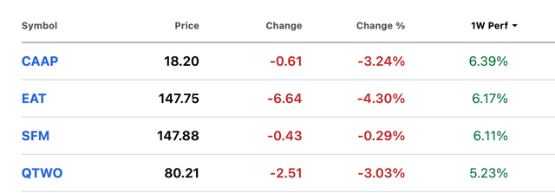](https://static.seekingalpha.com/uploads/2025/3/28/56421291-1743190047599193_origin.png)

Market data as of mid-day trading March 28th, 2025. (SA Premium)

Alpha Picks’ tech stocks were the biggest losers for the week, consistent with broader sector performance.

**Alpha Picks Weekly Losers**

[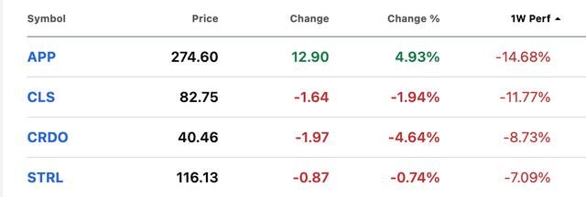](https://static.seekingalpha.com/uploads/2025/3/28/56421291-17431900475258627_origin.png)

Market data as of mid-day trading March 28th, 2025. (SA Premium)

**Economic Rundown**

* **Fed Policy**: Policymakers remain data-dependent, with PCE inflation critical for rate path signals. Rates held at 4.25%-4.50% as the median 2025 projection still implies two cuts.
* **Inflation**: Auto tariffs, including vehicle and parts costs, could add to core CPI. The core PCE forecast was raised to 2.8% for 2025 (from 2.5% in December).
* **Labor Market**: The unemployment rate was projected at 4.4% in 2025, up from the prior estimate of 4.3%. February’s JOLTS data is slated to be released on Tuesday, April 1st.

[Seeking Alpha Earnings Calendar](https://seekingalpha.com/earnings/earnings-calendar?source=first_level_url%3Aalpha-picks%3Aarticles%7Ccontent_type%3Aall%7Csection%3Aapb_article%7Csection_asset%3Abody_link%7Cservice_id%3A1409%7Cservice_name%3AAlpha%20Picks%7Cservice_level%3Abasic)

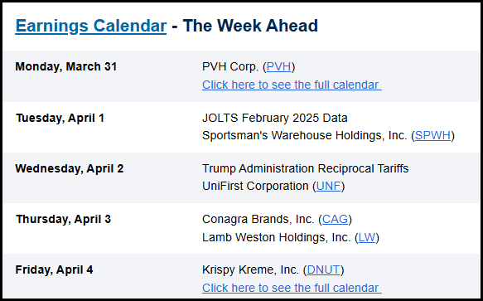

\*I/we have a beneficial long position in the shares of APP, EAT, CLS, and CRDO either through stock ownership, options, or other derivatives.